RTL INNOVATE: DIGITAL VLSI HACKFEST
TEAM: XRUN

TEAM MEMBER:
MEET KUMAR DUBEY
UJJAWAL SINGH

Problem Explanation
The problem is to design a synchronous FIFO (First-In First-Out) memory system using Verilog. The goal is to store data in such a way that the first data entered is the first data that comes out. The system should operate using a single clock and must support both read and write operations. It should also correctly indicate when the FIFO is full or empty to prevent invalid operations like overflow and underflow.

- Logic Used
The design is implemented using a combination of sequential and combinational logic. Flip-flops are used to store the write pointer, read pointer, and count, which update on the clock edge. Combinational logic is used to generate control signals such as full and empty and to decide when read or write operations are allowed.
The write operation occurs only when the FIFO is not full, and the read operation occurs only when it is not empty. A counter is used to track how many elements are stored in the FIFO. When writing, the count increases, and when reading, it decreases. If both read and write happen at the same time, the count remains unchanged. The pointers automatically increment and wrap around, creating a circular buffer.

- Block Diagram
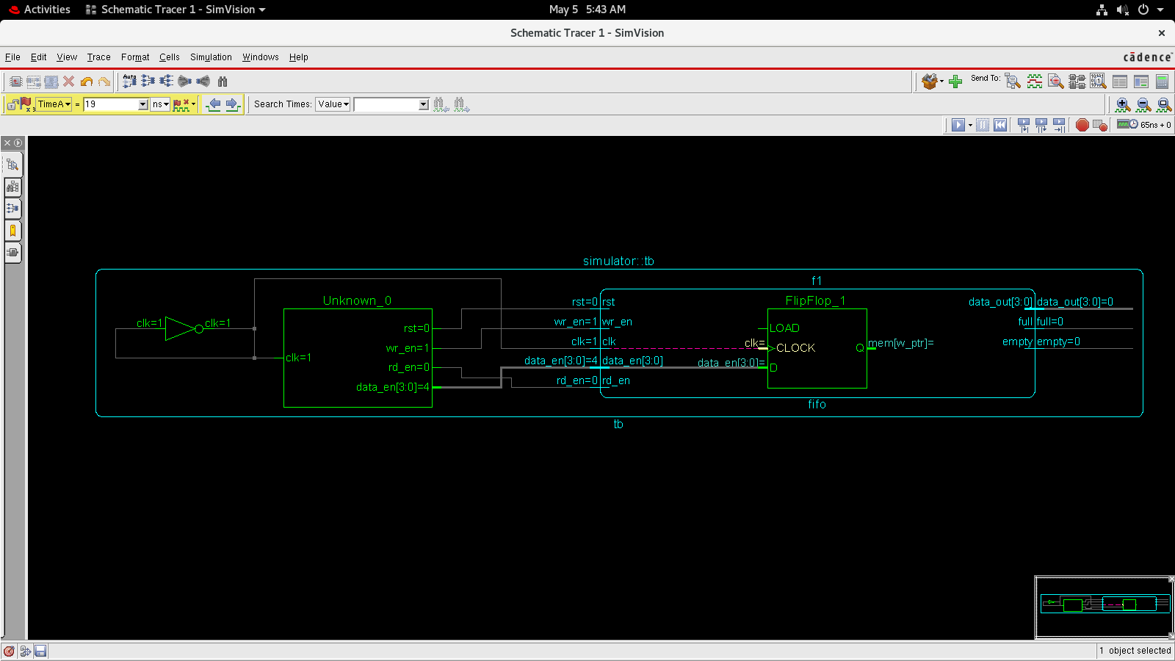

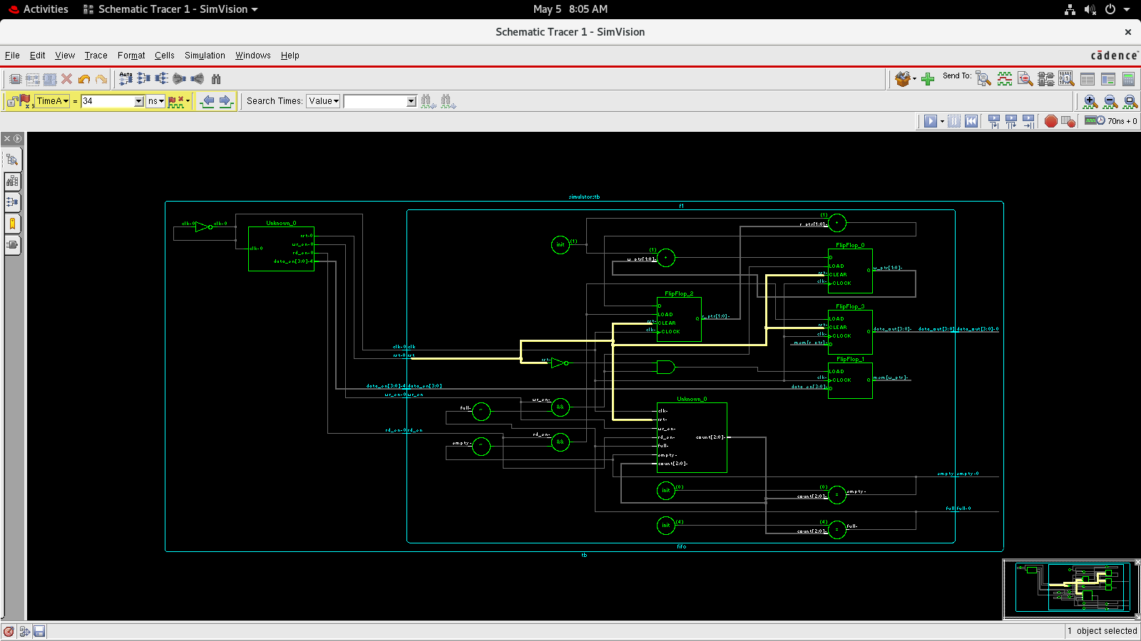

- Code Explanation
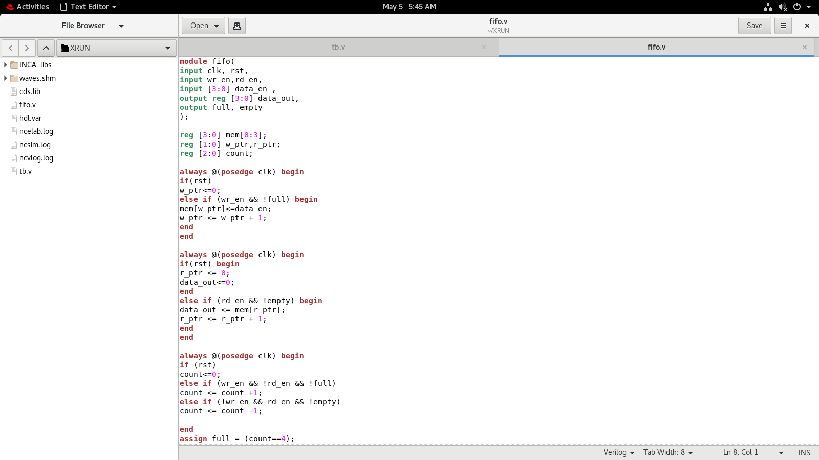
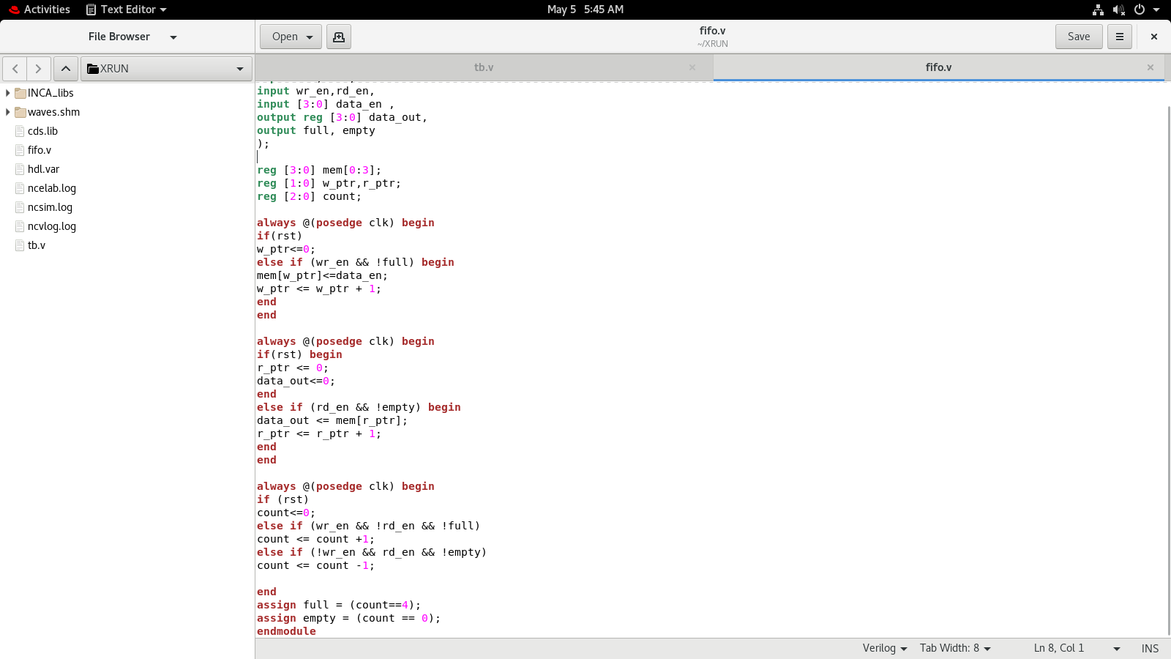

The FIFO is implemented using a memory array of four locations, each storing 4-bit data. Two pointers are used: the write pointer to store incoming data and the read pointer to fetch data. A counter keeps track of how many elements are currently stored.
During a write operation, data is stored in memory at the location pointed to by the write pointer, and the pointer is incremented. During a read operation, data is taken from the location pointed to by the read pointer, and the pointer is incremented. The full signal becomes active when the count reaches the maximum depth, and the empty signal becomes active when the count becomes zero. The design also handles simultaneous read and write operations correctly.

- Testbench Details
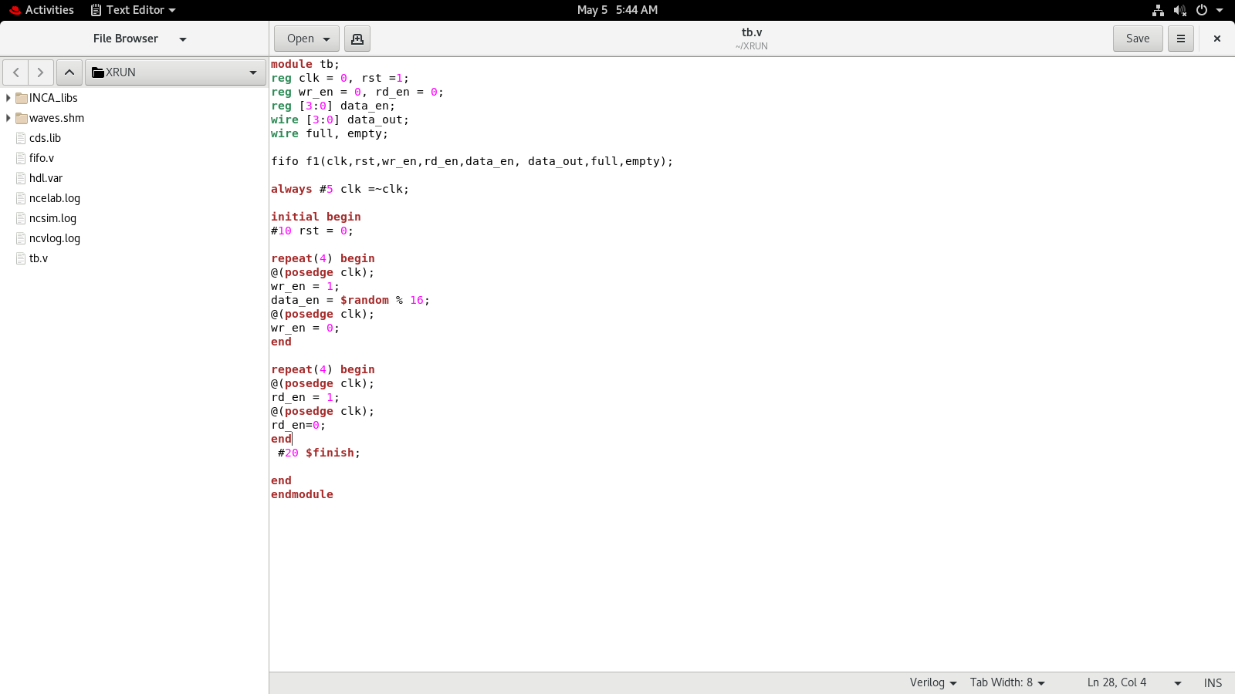

The testbench is used to verify the functionality of the FIFO. It generates a clock signal and applies a reset at the beginning. After reset, the testbench first writes multiple data values into the FIFO by enabling the write signal. Then, it reads the data by enabling the read signal.
The testbench ensures that data is written and read in the correct order and checks the behavior of the FIFO under different conditions. It uses clock-synchronized operations to accurately simulate real hardware behavior.

- Waveform Analysis

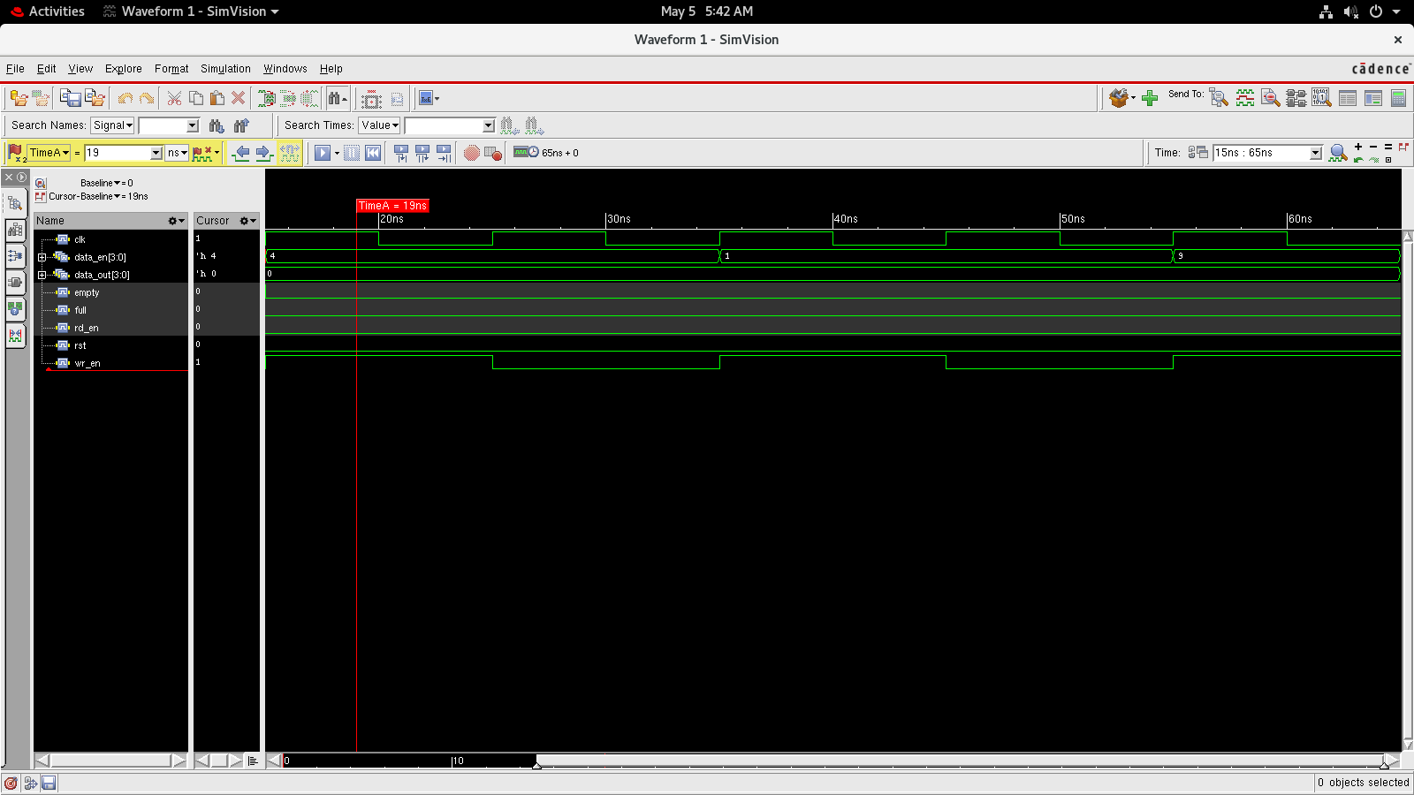

The waveform shows the correct operation of the FIFO. During the write phase, the write enable signal is active, and data is stored in memory. During the read phase, the read enable signal is active, and data is retrieved in the same order it was written. The count signal increases during write operations and decreases during read operations. The full and empty signals correctly indicate the status of the FIFO.

- Challenges Faced
During the implementation, one of the main challenges was handling the simultaneous read and write condition correctly, as it required ensuring that the count value remains unchanged. Another issue faced was simulation errors due to duplicate module names in the working library, which was resolved by cleaning the project and recompiling. There were also minor syntax errors such as missing semicolons and improper testbench timing, which were fixed to achieve correct simulation results. Ensuring proper synchronization with the clock in the testbench was also an important step to obtain accurate waveforms.

GITHUB REPO LINK
https://github.com/Meet958/SYNCHRONOUS-FIFO-VERILOG-IMPLEMENTATION/tree/main

